**WEEK 3 and 4 output documentation**



**Documentation**

Fundamentals of Data Science

UFCFK1-15-0

**Submitted by:**

**Name:** Shrawan Budhathoki

**Section:** I

**Student ID:** 25024656

**Github url:**

**https://github.com/kopiko2910/FODs-tasks.git**

**Question 1**

This is a program that has a function called cal_operation. Addition, Subtraction, Multiplication, and Division. The function is called at the end and results are printed.

**Input and output**

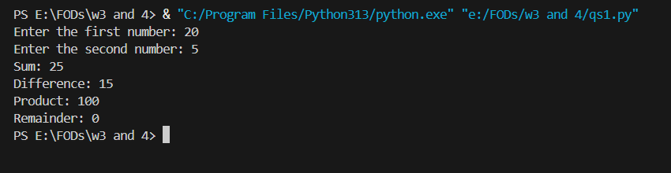

**Question 2**

Separate function to perform separate calculations. All functions are called at the end and output is printed.

**Input and output**

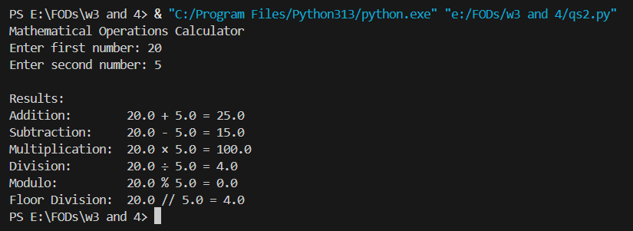

**Question 3**

This is a program having a function to find a factorial of a number.

**Input and output**

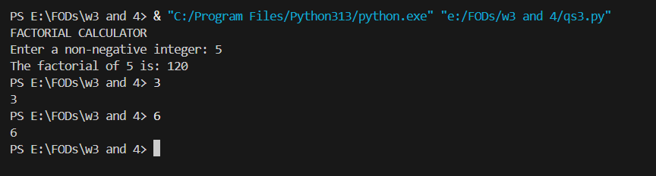

**Question 4**

This is a program that accepts a list of numbers and prints its occurrence using lists.

**Input and output**

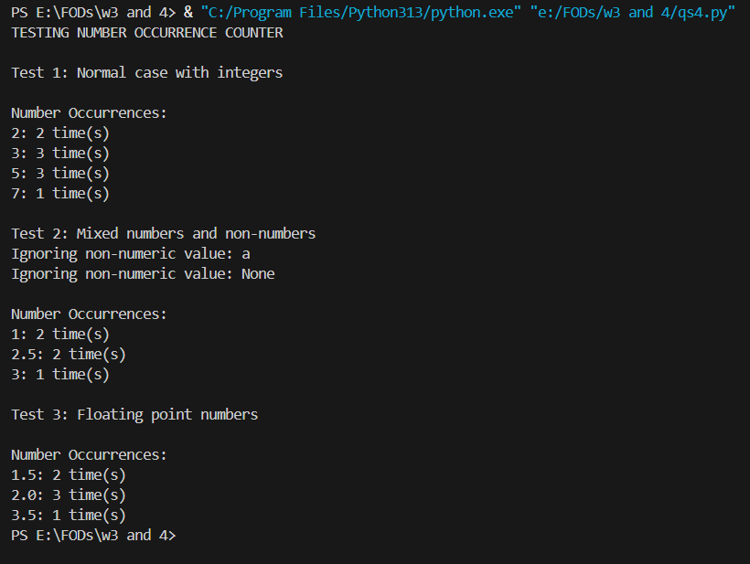

**Question 5**

This program accepts a list of names and prints the sorted lists.

**Input and output**

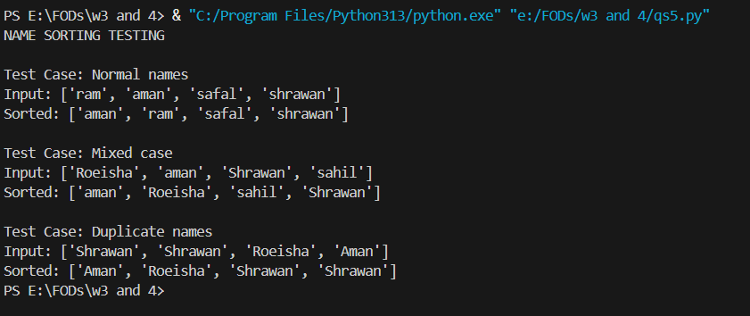

**Question 6**

This is a program where a city is entered. The program looks for the city in the list and gives output. If the city is not in the list, it gives proper error.

**Input and output**

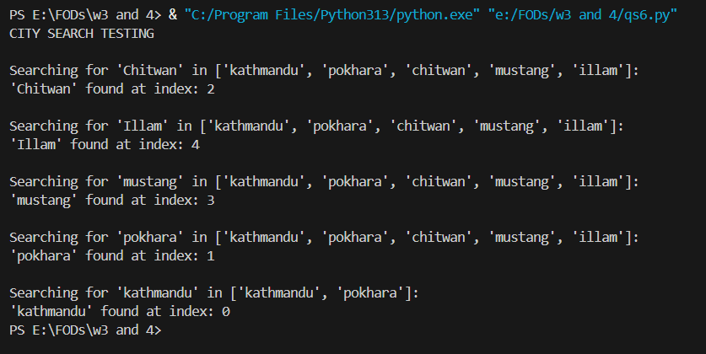

**Question 7**

This program takes a sentence as input, splits it and returns a dictionary containing the frequency of the word of that sentence.

**Input and output**

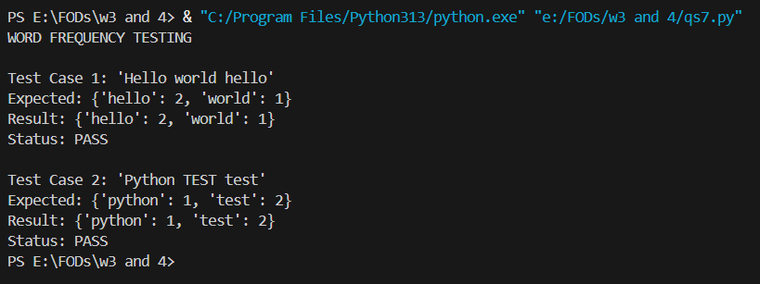

**Question 8**

This program takes a list of numbers and returns the list after removing the duplicate values.

**Input and output**

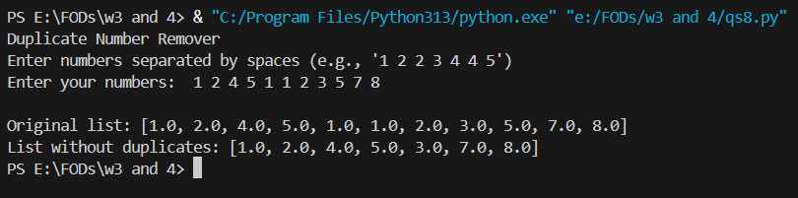

**Question 9**

This program takes a detail of 5 books such as ID, Author and stores them in dictionary. At last, it prints all the details.

**Input and output**

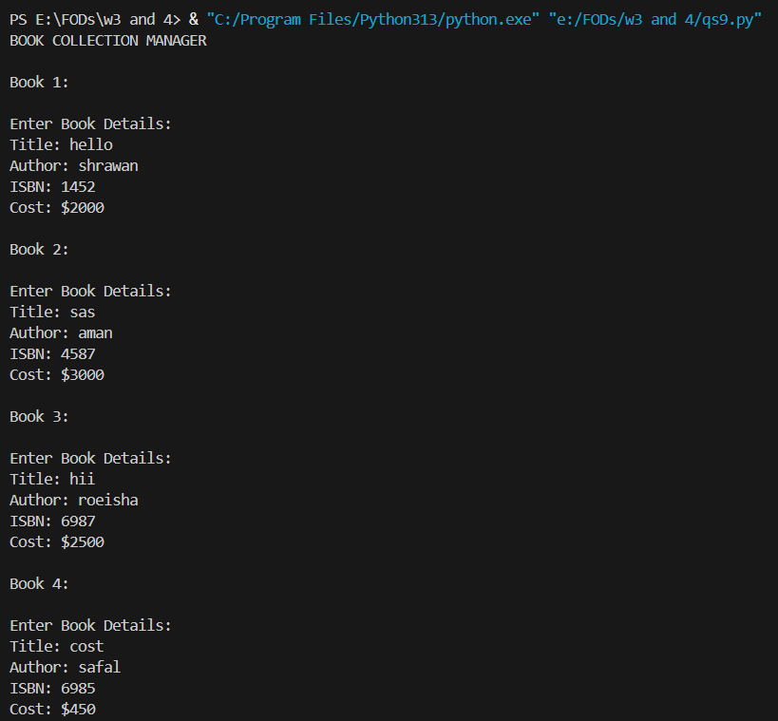

**Question 10**

This program takes the input from the user as much as they want and at last list of even and odd numbers are printed. Loops are used as necessary.

**Input and output**

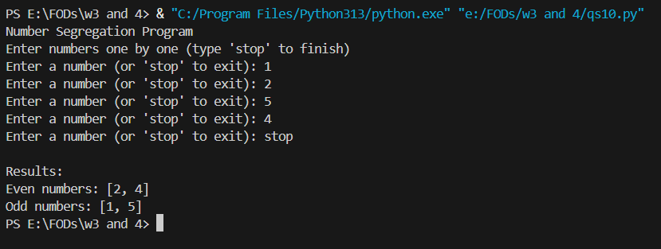

**Question 11**

This program is a simple card guessing game made using random module. The user can guess the number of cards alongside the type of card. Results are printed accordingly based on guessing only the number or only the type or both.

**Input and output**

